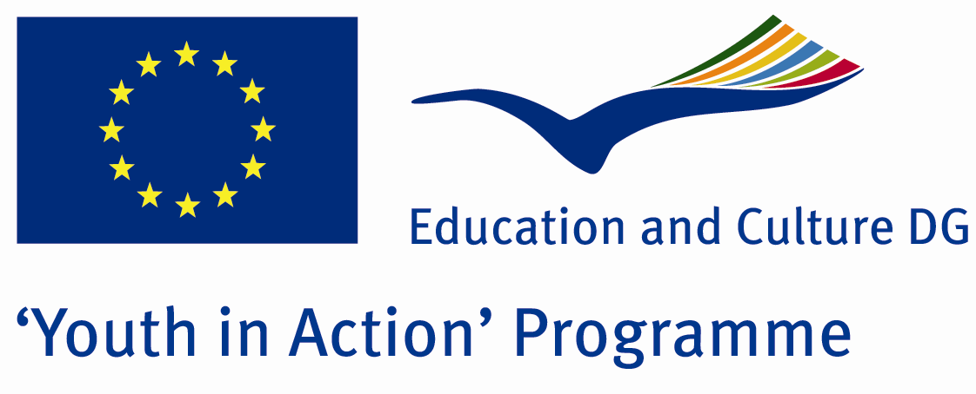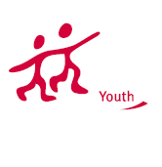

Music Colour
Bridges of Tradition

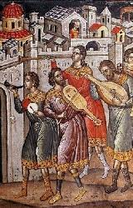

ACTION 1.1 – Youth Exchange

8-14th November , 2011

Thessaloniki, GREECE

ACTION 1.1 Youth Exchange

8-14th November , 2011

Thessaloniki, GREECE

Please contact directly to:
brailletheo@gmail.com

Project Summary:

Music is an international language. There are a lot of similarities between the traditional music of each country.
Here in this Project, each partner will present traditional music, hymns and traditional instruments from its country. We will discuss and try to learn about the use of the traditional music scales like Byzantine music chant, makams, chords, music therapy and religious music.
Activity 1: Εach group partner will choose and prepare to present traditional music from its own traditional music culture.
Activity 2: Εach group partner will speak and teach about traditional music to the other partners.
Activity 3. Finally we will make together an open to the public presentation of our work and we will record a cd with traditional carols and songs. This action will be also supported by St Panteleimon Parish in Kalamaria and the Music School of Thessaloniki.
In this project we will try to discover how traditional music colours work!

Project Title: Music Colour Bridges of Tradition

Date and Venue: 8-14th November 2011 Thessaloniki, Greece.

Target Group: Municipalities, City Councils and Non-Governmental organizations,
youth groups,culture and art groups that have to do with traditional music

Participants: 5 people from each country (over 13 -25 ) and one leader for each group. Totally 4 countries.

Conditions: Accommodation, board and programme costs will be financed through European Commission Youth in Action Programme (Action 1.1). Travel costs will be reimbursed in 70%. Organizations from all 27 EU member countries plus Liechtenstein , Norway and Iceland are eligible to take part.

Working language: English

Organizer: Volunteer singers of St Panteleimon Kalamaria/ Youth Choir of St Panteleimon Church Kalamaria
How to apply

Step 1: If you are interested, please complete, and send your Part III form
to 0030 2310 330488 by FAX please.
In this address you can download the form:
https://sites.google.com/site/choragpant/volunteer-singers-of-st-panteleimon-kalamaria/PartIIIform.doc?attredirects=0&d=1

Note1: Don’t forget to sign and stamp the form
Note2: jpeg is not allowed, please send by fax and then by post

Step 2
Original send your form via regular post to this address please:

Fr Theodor Tsampatzidis
Drakopulu 40
Gr-55132 Kalamaria Thessaloniki
Greece

Step 3
Please send 1-2 music videos of your group to this email address:
brailletheo@gmail.com

Deadline for application: until 25 March 2011.

For Further information:
Contact Person
Fr Theodor Tsampatzidis
Drakopulu 40
Gr-55132 Kalamaria Thessaloniki
Greece

e-mail : brailletheo@gmail.com
Mobile : 0030 6940737564
Fax : 0030 2310330488
Choir Site :
https://sites.google.com/site/choragpant/volunteer-singers-of-st-panteleimon-kalamaria

